**Guidelines for VCH Operating Rooms and Tissue Collection**

**INTRODUCTION**

The purpose of this guideline is to describe the process for review and approval of a research study (including tissue banking) that impacts the VCH Operating Room (OR) and that may involve the collection of tissue specimens for research purposes from the OR.

***ALL RESEARCH FORMS ARE LOCATED ON THE*** [***VCHRI WEBSITE***](https://www.vchri.ca/services/operational-approval)***.***

**TERMS**

**OR PSM –** Operating Room Patient Service Manager **or** Manager, Equipment and Supplies  
**PI –** Principal Investigator  
**PSM –** Patient Service Manager  
**VCH –** Vancouver Coastal Health Authority  
**VCHRI –** Vancouver Coastal Health Research Institute

**PROCEDURES**

**1. Research Studies impacting OR**

1.1 All research studies that impact the OR must be reviewed and approved by the OR prior to the start of the research study.

1.2 The following documents must be submitted to the OR PSM for review:

**i) Study Protocol  
ii) Application for Operational Approval to Conduct a Research Study at VCH (OA form) & Community of Care (CoC) Signature Sheet  
iii) OR Research Form  
iv) Specimen Collection for Research – Special Handling Instructions Form, aka Green Sheet (if applicable)**

1.3 The OR PSM will review the documentation listed in Section 1.2 for all research studies, regardless of if the procedure is considered standard of care or research.

1.3.1 If the OR will be impact by the research, the OR PSM will sign the OA form once all OR requirements have been met. The signature of the PSM confirms that:

* The OR has been notified of the research study and,
* OR will provide the necessary resources for the research study.

1.3.2 If the OR will **NOT** be impacted, the OR PSM will state on the form that there is “no involvement of the OR.”

1.3.3 A copy of the signed **‘Community of Care (CoC) Signature Sheet’** and the **‘OR Research Form’,** together with all applicable VCHRI documents must be submitted to VCHRI Research Approval Coordinator, for final review.

**2. Research Studies involving Collection of Tissue Specimen in the OR for Research Purposes***(APPROVAL FROM ANATOMICAL PATHOLOGY REQUIRED)*

**VCH PATHOLOGY MUST REVIEW AND APPROVE THE RESEARCH STUDY PRIOR TO THE OR.**

2.1 The following documents must be submitted to VCH Pathology for review:

**i) Study Protocol  
 ii) Application for Operational Approval to Conduct a Research study at VCH (OA form) & CoC Signature sheet  
 iii) Anatomic Pathology Laboratory Resource Utilization form  
iv) Specimen Collection for Research – Special Handling Instructions Form, aka Green Sheet** *(if special handling is required for tissue specimen collection in the OR)***v) A Copy of the Ethics Application**

2.1.1 If VCH Pathology agrees that the standard route for sending tissue specimens to VCH Pathology is not appropriate, VCH Pathology will sign the **Green Sheet.**

2.1.2 By signing the **Green Sheet,**

* VCH pathology agrees that special handling or a “RUSH” procedure may be necessary.
* VCH pathology is aware of the urgent need to process the sample, and/or
* VCH pathology is aware of the special handling instructions.

2.2 Once the above documents have been reviewed and approved by VCH Pathology, then OR **must** receive the appropriate documentation for review (refer to section 1.2)

**VCHRI APPROVAL**

VCHRI will review all the documentation submitted to and approved by the OR and VCH Pathology.

Once the VCH Certificate of Approval is issued by VCHRI, VCHRI will photocopy the **Specimen Collection for Research – Special Handling Instructions Form, aka Green Sheet** for the PI. This form must be attached to the OR chartlet including a copy of the informed consent.

**Collecting Tissue Specimens**

1. **Prior to Surgery**a) Requirement of Informed Consent
   * 1. If a patient is undergoing surgery in a VCH operating room, and tissue will be collected during surgery for research purposes, informed consent must be obtained from the patient prior to his/her surgery.
     2. Research subjects must have adequate time between initial contact to the actual consent phase to consider participating in the research.   
          
        The PI or designate is responsible for dropping off the OR research document (a copy of the signature page of informed consent form) at VGH JPPN 2nd or 3rd floor Peri-operative care clinic.
     3. If applicable, the **Green Sheet** must be attached to the front of each OR chartlet. The PI or designate must remember to complete the question relating to informed consent on the **Green Sheet** (question in the shaded box) before the **Green Sheet** is placed on the chart.
   1. Submitting **UBC Hospital (UBCH) OR documents (if applicable)**

2 days or the day before surgery, the OR research documents are placed on the chart in the appropriate area *(Refer to Appendices A – C)*:

* + - 1. VGH Mailroom Drop off Box (if the day before, preferably BEFORE 11AM)
      2. In person at Peri-operative clinic at UBCH

The following OR documents must be submitted to UBC Hospital:  
1. **Specimen Collection for Research – Special Handling Instructions Form, aka Green Sheet**2. Signature page of informed consent form

Researchers can drop off labelled envelop in the grey bin on a metal cart located at VGH mailroom or hand it to the mailroom clerk in an envelope labeled OR Greensheet. OR research documents should be dropped off 2 days prior to scheduled surgery or by Friday for the following week (*Note: UBCH Surgical is closed on weekends) Refer to Appendix C*

**IF A COPY OF THE SIGNATURE PAGE OF INFORMED CONSENT IS NOT PLACED ON THE OR CHARTLET PRIOR TO SURGERY, THE TISSUE WILL BE SENT TO PATHOLOGY ACCORDING TO STANDARD PROTOCOL. IT BECOMES THE RESPONSIBILITY OF THE RESEARCHER TO FOLLOW UP WITH THE VCH PATHOLOGY REGARDING CORRECT HANDLING OF THE TISSUE SPECIMEN.**

1. **In the OR**
   1. Once the tissue sample is collected, the OR nurse will complete the “M140 Surgical Pathology Consultation Requisition”. The OR nurse will confirm with the surgeon that the tissue specimen is required for research purposes. If additional tissue has been collected for research purposes, the surgeon will advise which tissue specimen is for research purposes, and which specimen is for clinical purposes. If there is any uncertainty about which specimen has been collected for research purposes, VCH pathology will contact the surgeon directly to clarify.  
      1. If the surgeon confirms that the tissue specimen is for research purposes, research is indicated by the “research institute” number in the “M140 Surgical Pathology Consultation Requisition”.

Note: Proper documentation is required as mentioned above in **RED**. OR does not follow verbal research requests.  
  
The tissue specimen will be sent to VCH pathology, along with a copy of the signature page of informed consent. The tissue specimen will be sent according to routine protocol (distribution or tube) or as indicated on the **Green Sheet.** The **Green Sheet** is sent to VCH pathology together with the tissue specimen.

* + 1. If the surgeon advises that the tissue specimen is **NOT** related to research, the tissue specimen will be sent to VCH pathology according to routine protocol (distribution or tube) with the “M140 Surgical Pathology Consultation Requisition” and will be processed for diagnostic purposes only.
    2. If there is more than one research specimen collected in a case (i.e. during one surgical episode), it will not be necessary to attach a copy of the signature page of informed consent to each “M140 Surgical Pathology Consultation Requisition”. A copy of the signature page of informed consent will only be required for the first tissue specimen collected during the surgical episode.

1. **In VCH Pathology**
   1. When the tissue specimen is received by accessioning staff, the “M140 Surgical Pathology Consultation Requisition” will be reviewed to confirm that the tissue specimen was collected for research purposes.
   2. The tissue specimen will then be directed to the VCH pathologist for processing and will be handled per instructions detailed on **Green Sheet** (The VCH pathologist is listed as a co-investigator on the UBC Ethics Certificate of Approval).
   3. If the PI has indicated on the “Anatomic Pathology Laboratory Resource Utilization Form” that the tissue specimen will be picked up from the VCH Pathology, the contact person listed on the “Anatomic Pathology Laboratory Resource Utilization Form” will be contacted and notified that the tissue specimen is ready for pick-up.
   4. Non-VCH research personnel are no longer able to obtain keycard access. They must knock on specimen drop-off door to gain access.

# **APPENDICES**

**APPENDIX A.** Map of Pathology

*Currently unavailable – map will be changing in May 2025. Please connect with AP or OR.*

**APPENDIX B.** Map of Perioperative Care Centre (PCC) at Jim Pattison

Where OR documents for VGH can be dropped off.

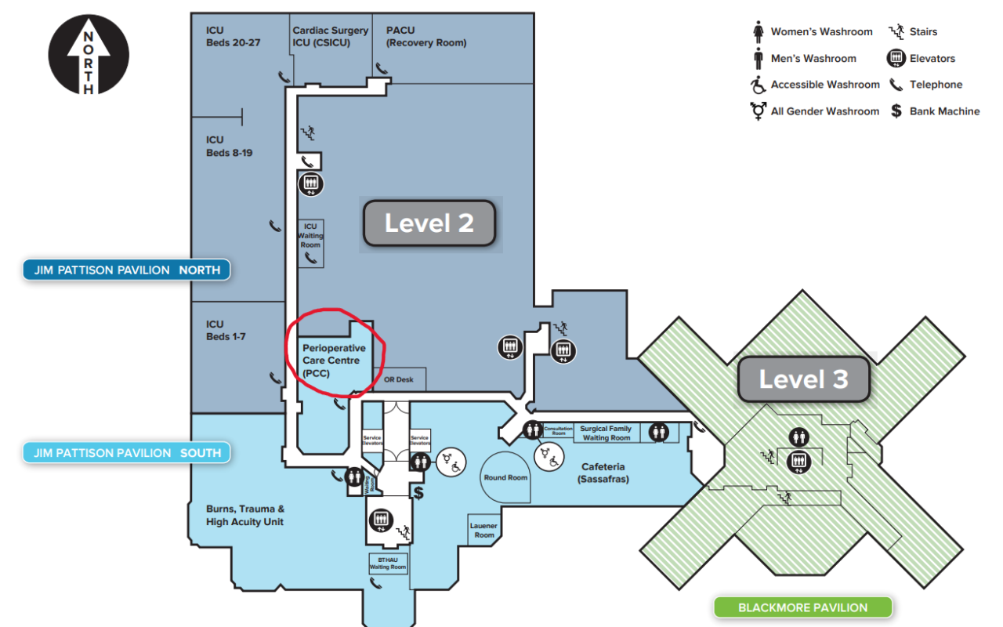

**APPENDIX C.** Map of VGH Mailroom

If OR documents will be sent and dropped off to UBC Hospital OR. Drop off the OR documents **2 days prior to scheduled surgery or by Friday for the following week** (*Note: UBCH Surgical is closed on weekends)*

